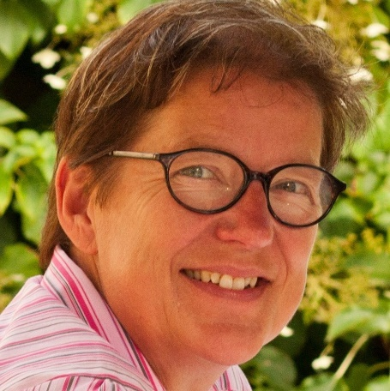
CV for Trine Smistrup
Phone: + 45 2042 1017
Mail: trine@journalismarena.eu, trine@smistrup.eu
Twitter/Whatsapp/Signal: tsmistrup
Office: Mediehuset Rubrik, Vandkunsten 6, 2., 1466 Kbh K Denmark
Home: Finsensvej 11A,3., DK-2000 Frederiksberg, Denmark

Freelance journalist, project coordinator, media trainer, web editor

Professional experience:
2007-present: Freelance journalist, project coordinator and trainer
International:
- Project director and communications officer for Arena for Journalism in Europe
- Editorial project coordinator for Journalismfund.eu
- Project coordinator SCOOP Russia
- Project coordinator in Russia for the Nordic Journalist Center

Media training:
- News writing, creative writing, writing for the internet
- Writing coach for newsrooms and individuals
- Organizer of study tours on international and media topics

Consultancies:
- Language policies and training for public institutions and private companies
Digital:
- Project coordinator for web projects
- Webmaster of Arena for Journalism in Europe, Dataharvest.eu, SCOOP International and several smaller websites

1993-2006: Deputy director, Danish Institute for Mid-Career Training in Journalism
- Head of Copenhagen office
- Course organizer
- Responsible for all international activities

2001-2003 Project director, Nordic Journalist Center
- Project director on two research projects
- Responsible for training projects and trainings needs assessment for journalists in Estonia, Latvia, Lithuania and Northwest Russia.

1988-1993 Berlingske Tidende (Danish national daily newspaper)
Sub editor, foreign desk, business desk

1984-1987 Frederiksborg Amts Avis (Danish regional daily newspaper)
Reporter, sub editor

Education:

2005 MA, Computer Mediated Communication, Roskilde University (DK)

1984 Danish School of Journalism, international affairs

1980: BA, Spanish, Aarhus University

Languages:
- Danish (mother tongue)
- English (excellent)
- Norwegian/Swedish (excellent)
- Spanish (good)
- German (good)
- French (fair)
- Russian (rudimentary)

